**1. If you just want it to work, follow this (RECOMMENDED) 👇**

Tools don't add that much functionality in new versions, so you're just fine using this method.

You will have to install the same package versions that I install in my videos. So instead of the npm install commands I use in the videos, use the following (we use @ to specify the version number)

* **For webpack:**

1. npm install --save-dev webpack@4 webpack-cli@2 webpack-dev-server@3

* **For babel:**

1. npm install --save-dev babel-core@6 babel-preset-env@1 babel-loader@7
2. npm install --save babel-polyfill@6

**2. If you want the latest versions, follow this 👇**

This method requires a little more work, as babel has recently changed how the configuration works.

* For webpack, just follow the videos.
* For babel, **instead** of installing babel-core, babel-preset-env and babel-polyfill in the babel lecture, please install @babel/core, @babel/preset-env, core-js@3, and regenerator-runtime like this:

npm install --save-dev @babel/core @babel/preset-env babel-loader npm install --save core-js@3 regenerator-runtime

You will also need to change the entry in webpack.config.js (a file we create during the video) from this:

1. entry: ['babel-polyfill', './src/js/index.js'],

to this:

1. entry: ['./src/js/index.js'],

and the code in .babelrc (also created during the video) from this:

1. {
2. "presets": [
3. ["env", {
4. "targets": {
5. "browsers": [
6. "last 5 versions",
7. "ie >= 8"
8. ]
9. }
10. }]
11. ]
12. }

to this:

1. {
2. "presets": [
3. ["@babel/env", {
4. "useBuiltIns": "usage",
5. "corejs": "3",
6. "targets": {
7. "browsers": [
8. "last 5 versions",
9. "ie >= 8"
10. ]
11. }
12. }]
13. ]
14. }

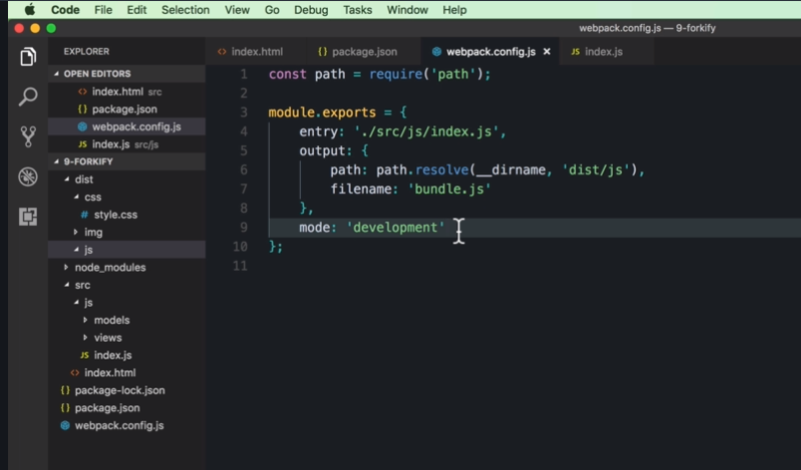

To trigger webpack we can us npm

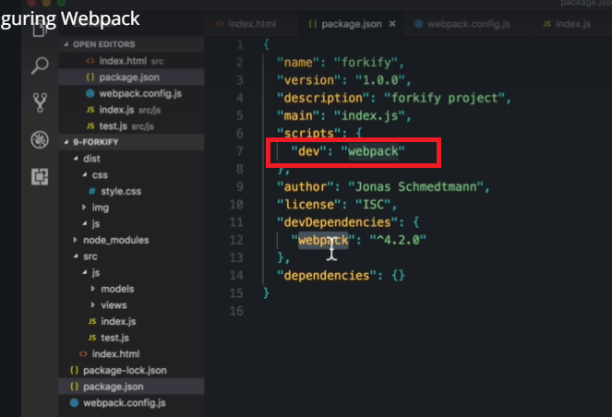

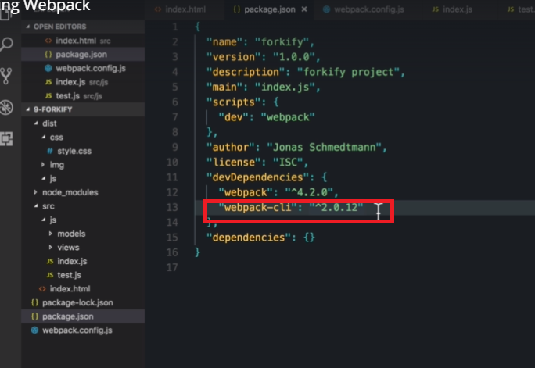

The mode from webpack,config..js can also be moved to package.json npm script

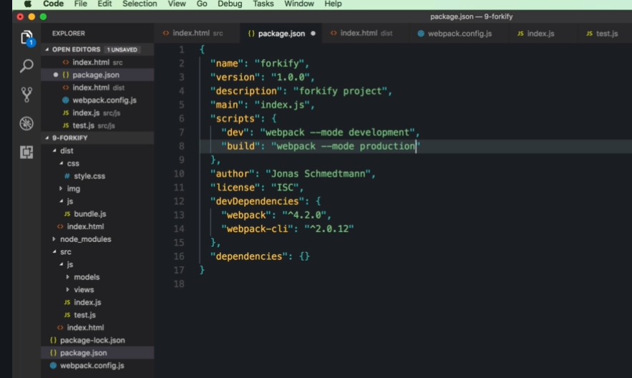

To automatically reload the page when we save the code

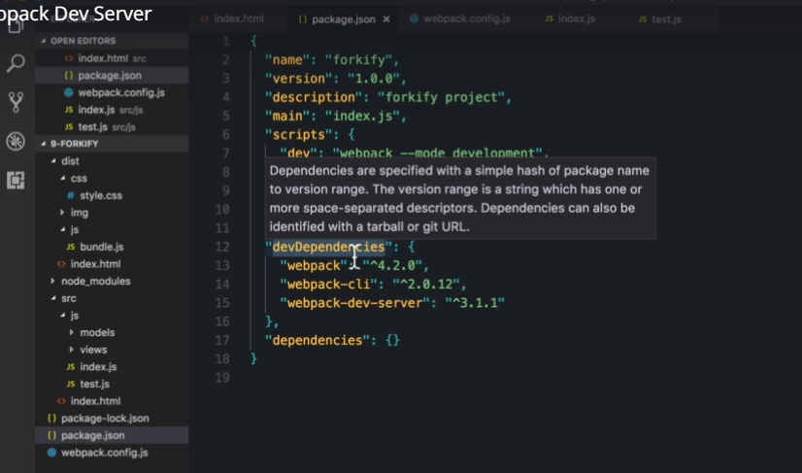

To configure the dev-server

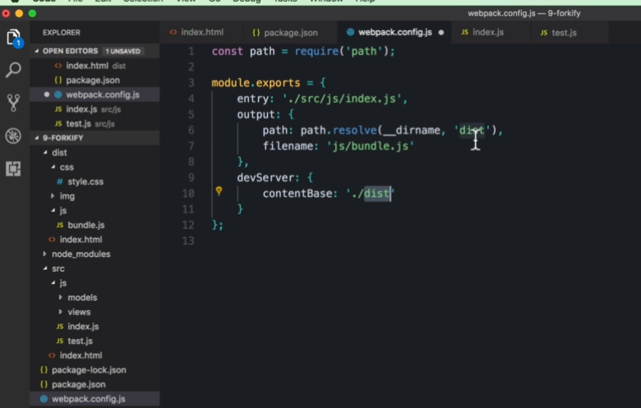

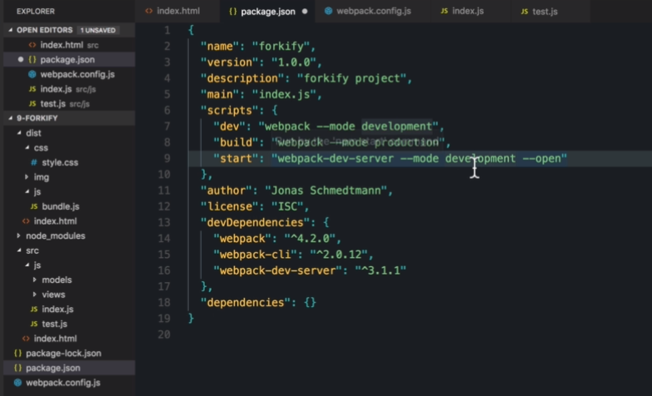

To install html webpack plugin----check notes

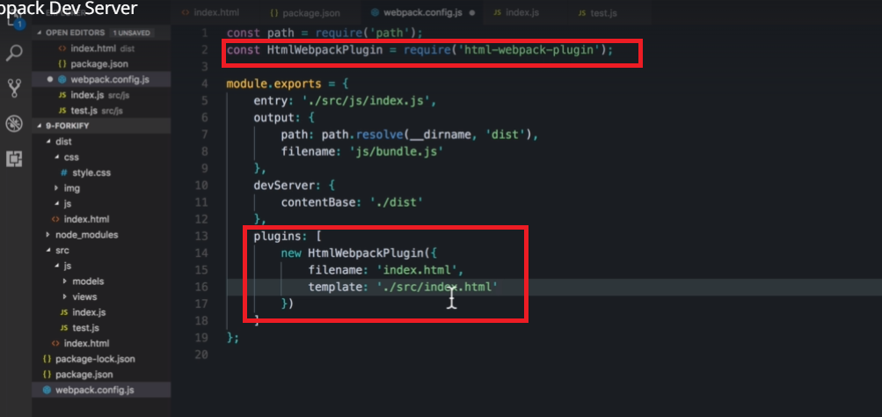

After installing Babel:

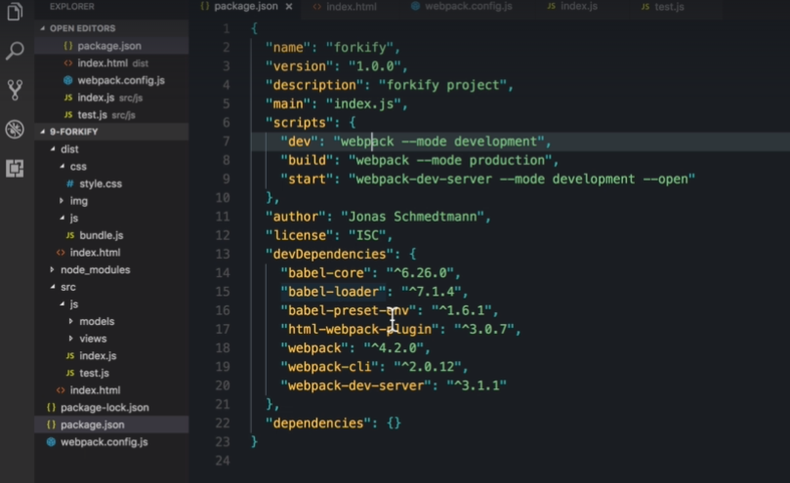

Adding Babel to webpack.config.js

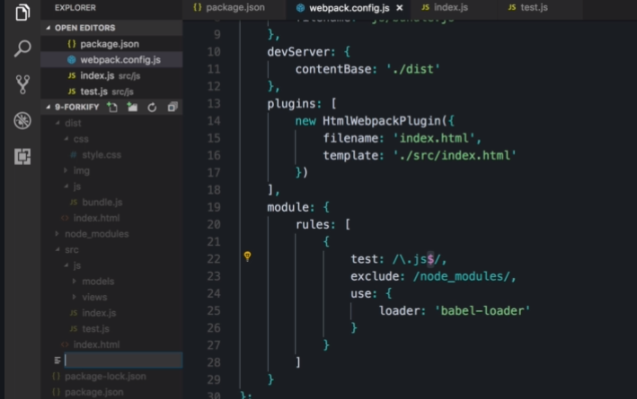

Creating babel config file

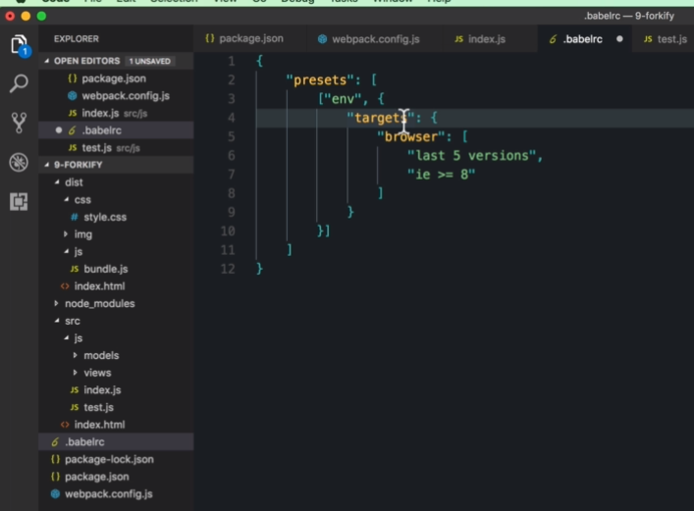

MVC

